1. **Header:**

# **Title**: Amino-acid transporters in T-cell activation and differentiation

**Why did I read this paper:** Broadly, to understand about transporter, specifically, about amino-acid transporters

# **Source:** <https://www.nature.com/articles/cddis2016222>

**Year of published:** 2017

1. **Summary of abstract**

* T-cell-mediated immune responses
  + protect mammals against cancers and infections
  + involved in the pathogenesis of various inflammatory or autoimmune diseases
* Cellular uptake and the utilization of nutrients is closely related to the T-cell fate decision and function. Research in this area has yielded surprising findings in the importance of amino-acid transporters for T-cell development, homeostasis, activation, differentiation and memory.

1. **Outstanding points**

* To protect the host from infection, T cells need to go through the following phases:
  + a beginning phase with massive clonal expansion and differentiation of T cells
  + a second phase, including the migration of T cells to relevant tissues, synthesis of cytokines and effector molecules, as well as the clearance of most effector cells
  + a final phase with the generation of memory T cells
* This process imposes considerable demands for **energy** and biosynthetic precursors
  + The uptake and utilization of nutrients highly affects T-cell development, homeostasis, activation, differentiation and memory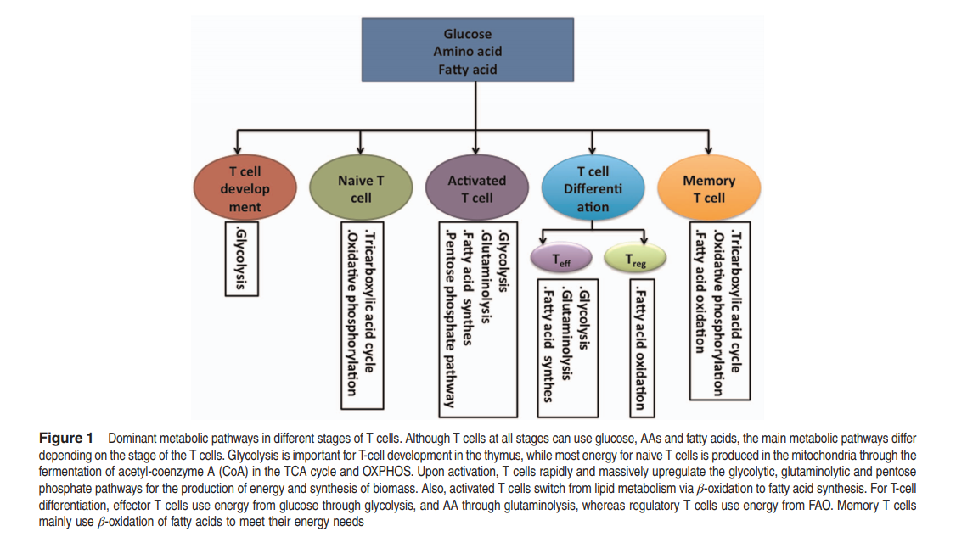T cells in each stage or even distinct T-cell subsets within a similar stage display unique metabolic programs (Figure 1)
  + There is increasing interest in regulating T-cell fate decision by modulating the abundance of nutrients in cells, expression of nutrient transporters and activation of metabolic pathways, especially for those of glucose and fatty acid
  + Amino acids (AA) or AA transporters are also crucial in T-cell-mediated immunity
    - activated T cells use glutamine (G amino acid) to fuel metabolism as a nitrogen source and as an anapleurotic substrate
* **The paper describes the role of AA transporter to T cell:**
  + Expression of AA transporter in T cells
  + AA transporters and intrathymic development of T cells
  + AA transporters and naïve T-cell homeostasis
  + AA transporters and activation of T cells
  + AA transporters and T-cell differentiation
  + AA transporters and T memory cells
  + Mechanism for AA transporters in shaping T-cell biology

1. **Lesson learned from the papers**
2. **Terms translated to Vietnamese**

|  |  |
| --- | --- |
| **Term** | **Translated** |
| T-cell-mediated immune responses |  |
| pathogenesis | Sự phát sinh bệnh |
| inflammatory | Dễ bị viêm |
| autoimmune diseases | Bệnh tự miễn dịch |
| homeostasis | Cân bằng nội mô |
| differentiation | Biệt hóa |
| ameliorate | Cải thiện |
| Clonal expansion | Nhân bản (dịch vậy ko biết được ko) |
| cytokines | Sự phân bào |
| effector molecules | is usually a small molecule that selectively binds to a protein and regulates its biological activity |
|  |  |
|  |  |

1. **Facts**

* The cellular metabolic pathways are associated with the shaping T-cell development, homeostasis, activation, differentiation and even memory.
* Amino acid transporters are critical for T-cell fate decision
* Amino acid transporters, such as LAT1, ASCT2, and GAT-1, have important roles in peripheral naive T-cell homeostasis, T-cell activation and differentiation, especially for Th1 and Th17 cells, and T-cell memory
* The influence of Amino acid transporters on T-cell fate decision may largely depend on mTORC1 signaling

1. **Novel knowledge**

* The discoveries (refered in the paper) remarkably demonstrate the role of amino-acid transporters in T-cell fate determination, and strongly indicate that manipulation of the amino-acid transporter-mTORC1 axis could ameliorate many inflammatory or autoimmune diseases associated with T-cell-based immune responses.
* “We believe that understanding the influence of AA transporters in T-cell fate determination offers significant insights into T-cell-based immune diseases and opens up novel potential treatments to prevent and cure T-cell-based immune pathologies through **modulation of the expression of AA transporters and the metabolism of AA in T cells**”

1. **Other notes**